

SIMATS ENGINEERING

Saveetha Institute of Medical and Technical Sciences
Chennai- 602105

Student Name: M.Nandhini Reg. No.:192472318
Course Code: CSA1071 Slot: C
Course Name: Software Engineering for DevOps Practices
Course Faculty: Dr.Bindu.G
Project Title:
FreelanceHub: Online FreelanceMarketplace and Collaboration Platform
Module Photographs:
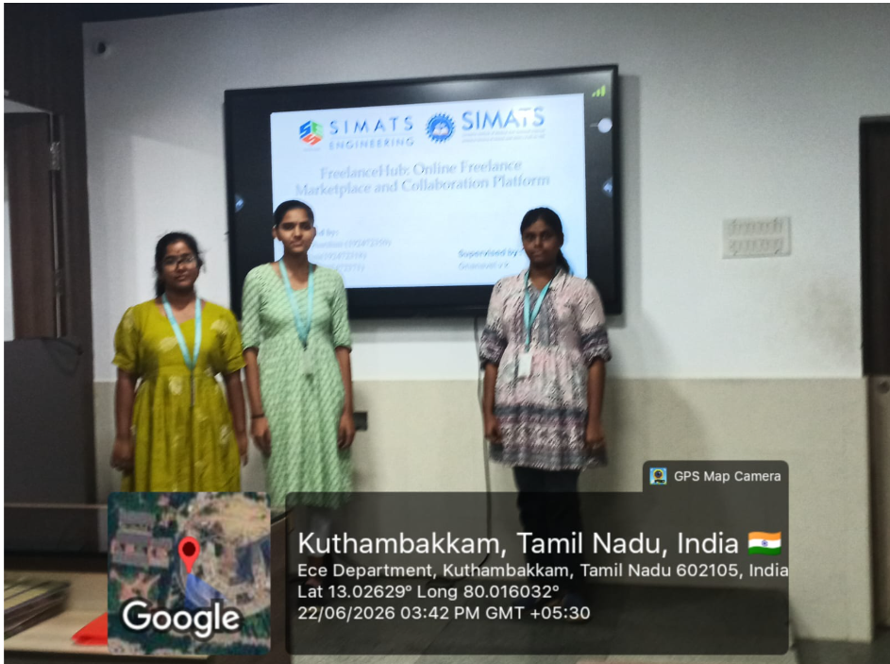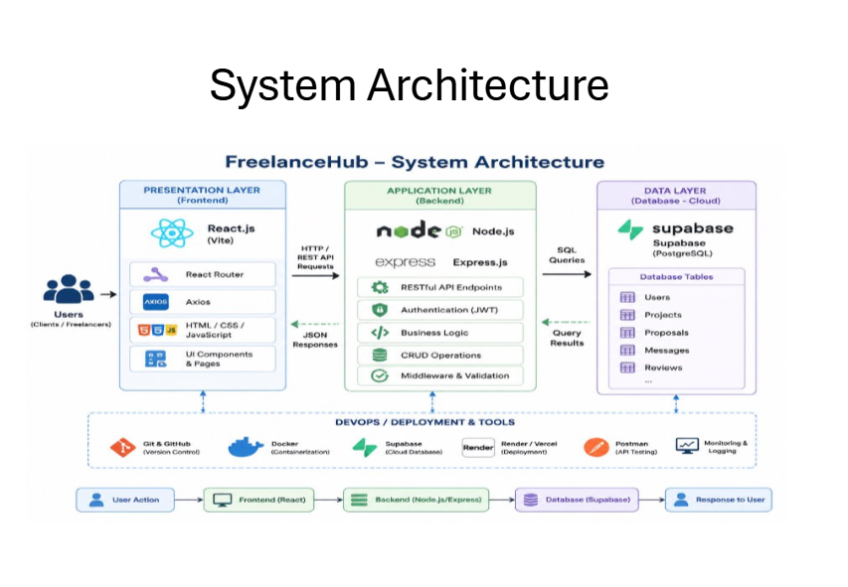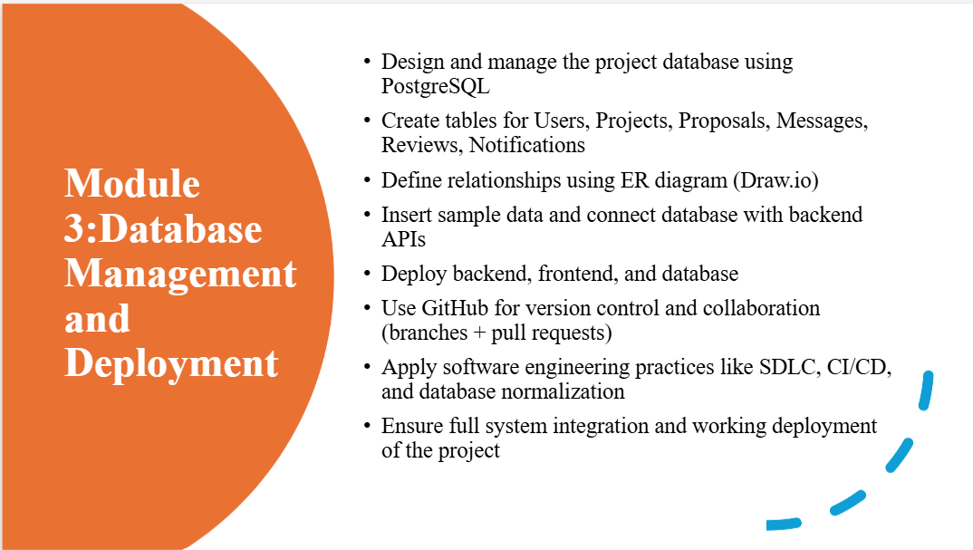
Project Description:
FreelanceHub is a full-stack web-based freelance marketplace platform that connects clients with freelancers to simplify project collaboration and management. The system allows users to create accounts, manage profiles, post and search for projects, submit proposals, communicate through messaging, and provide ratings and reviews. The application is developed following Software Development Life Cycle (SDLC) principles, including requirement analysis, system design, implementation, testing, and deployment. It is built using React.js for the frontend, Node.js and Express.js for the backend, and PostgreSQL for database management. The development process utilizes software engineering practices such as GitHub-based collaboration, Agile task management, UML and ER design, API testing, CI/CD, and cloud deployment using Vercel, Render, and Supabase. FreelanceHub is an online platform designed to connect clients with skilled freelancers. It allows users to register, create profiles, post and browse projects, submit proposals, communicate, and provide feedback. The application is developed as a software engineering project using modern web technologies, version control, testing methods, and deployment practices to create a reliable and user-friendly system.

Student Signature Guide Signature

